Find our
Elf on the Shelf
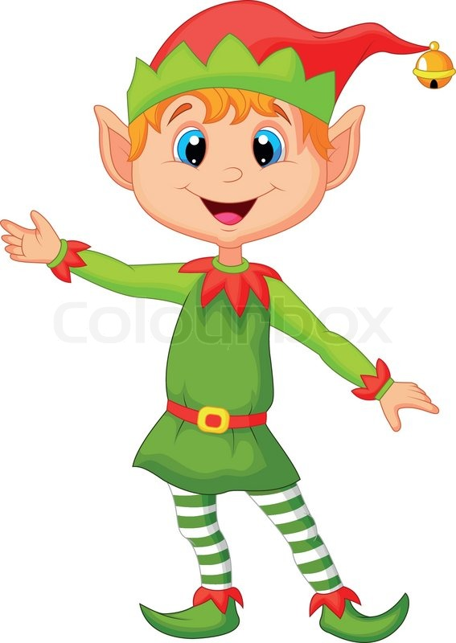
and receive a surprise!

